Total of 19 problems Please (see attachment (1)

Chapter 5
Problem 5.1
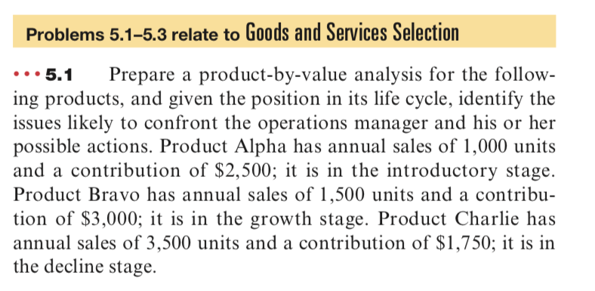

Problem 5.18
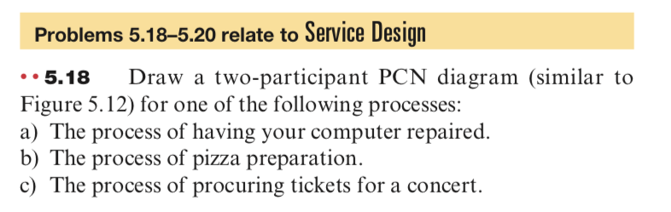

Chapter 5
Supplement: Sustainability in the Supply Chain
Problem 5.4 -5.5
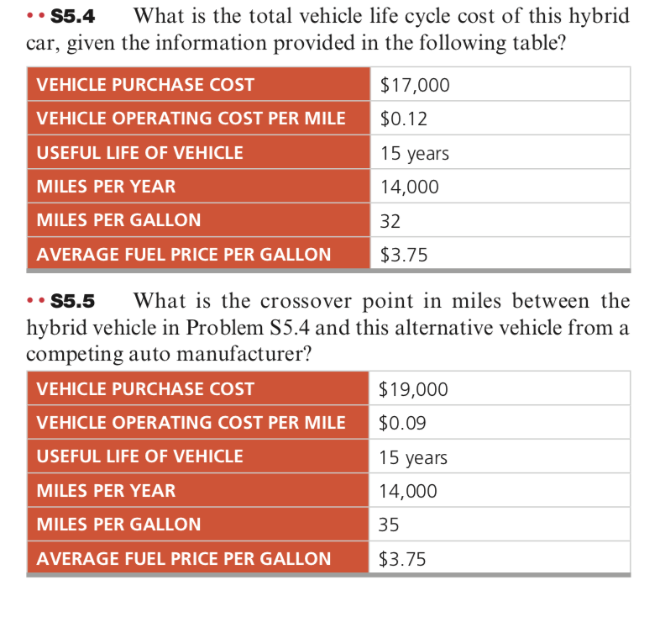

Chapter 6: Managing Quality
Problem 6.3
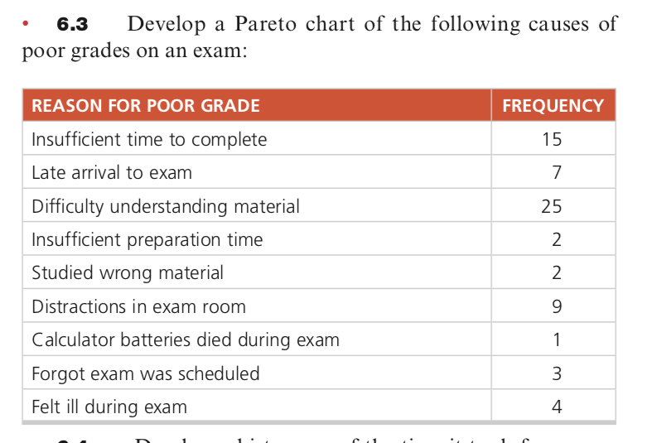

Problem 6.6

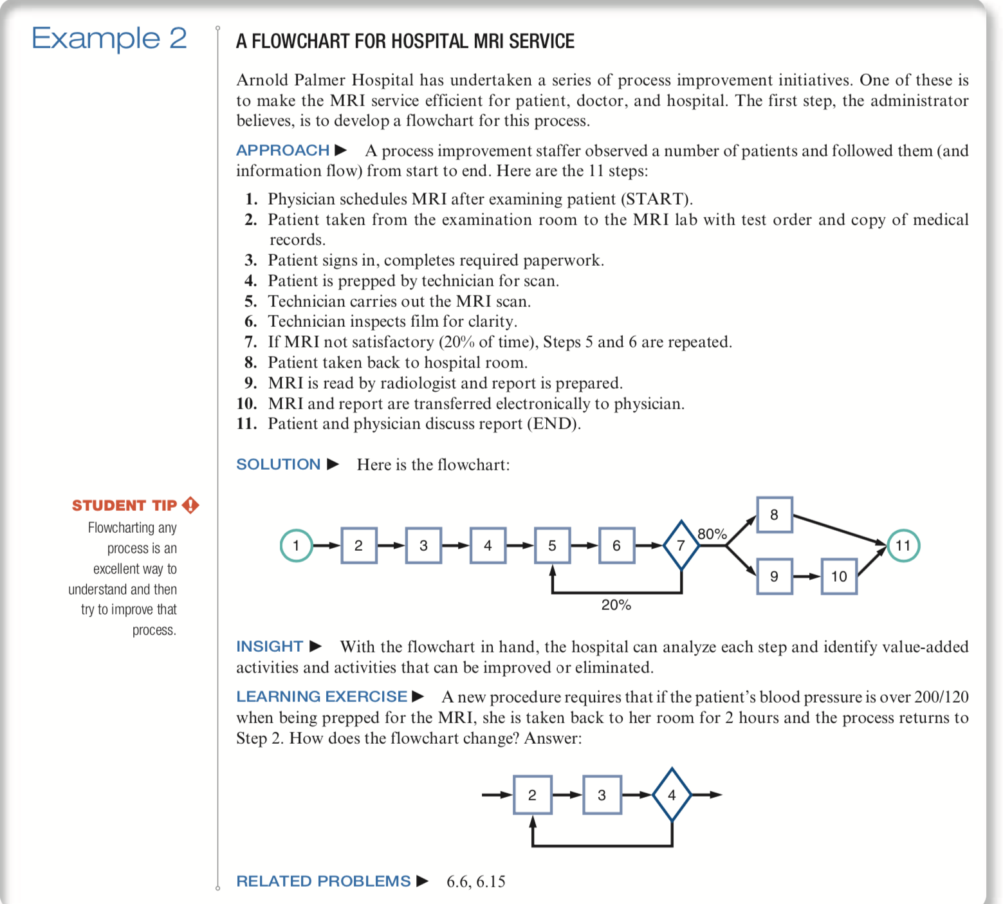

Chapter 6
Sustainability in the Supply Chain

Problem S6.1
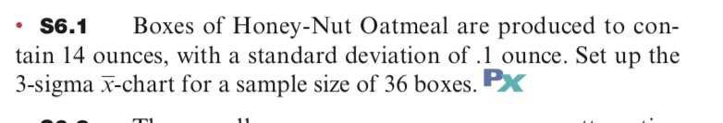

Problem S6.5
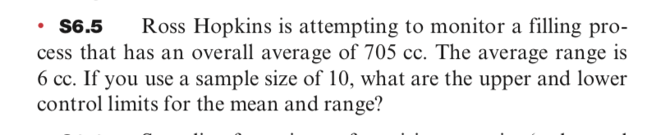

Process Strategy (3 Problems)

Chapter 7 problems
Problem 7.5
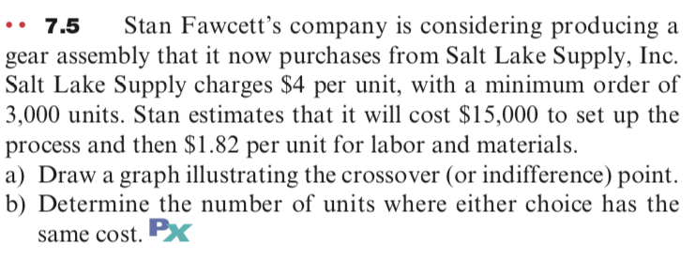

Problem 7.7
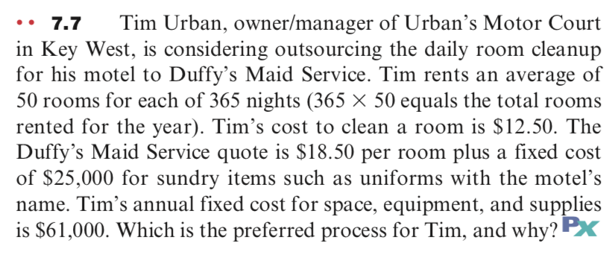

Problem 7.11
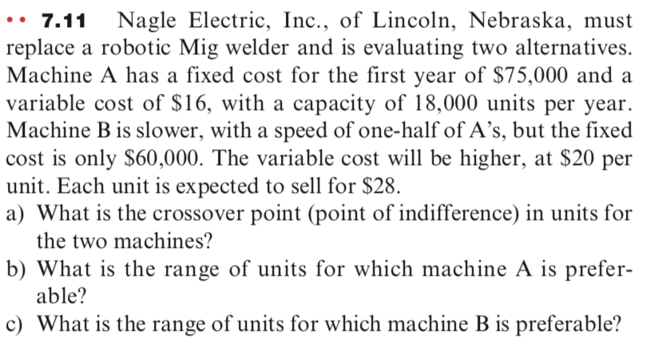

Supplement Capacity and Constraint Management (3 Problems)

Problem S7.21
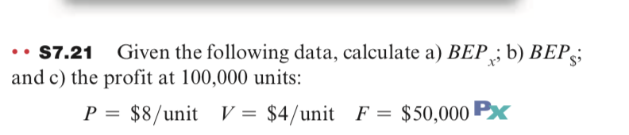

Problem S7.23
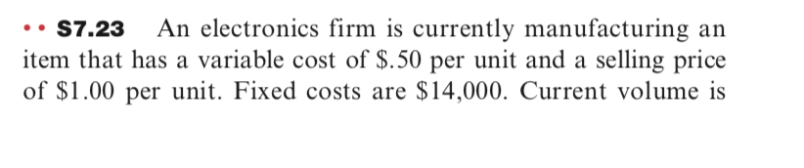

Problem S7.23 cont’d

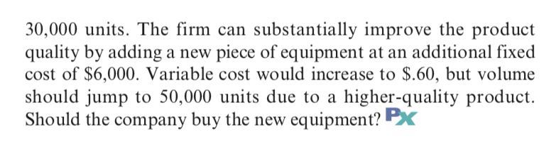

Problem S7.25
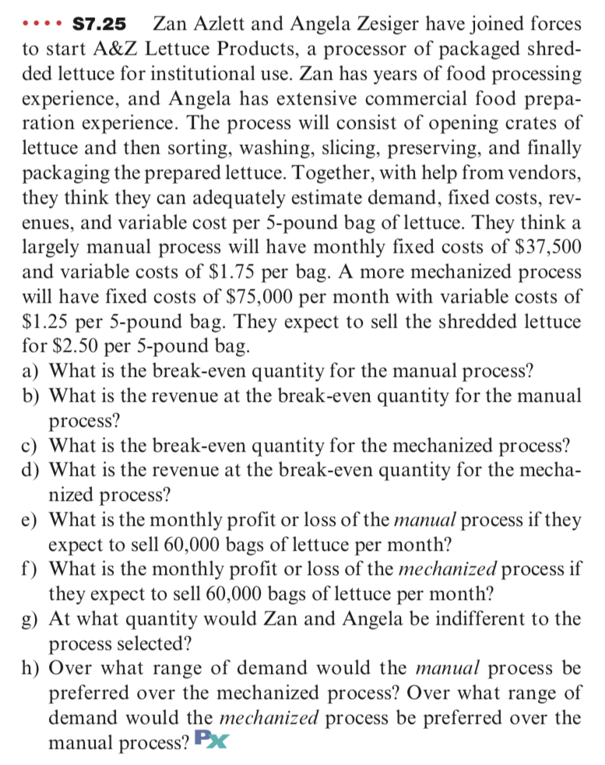

Problem 8.5
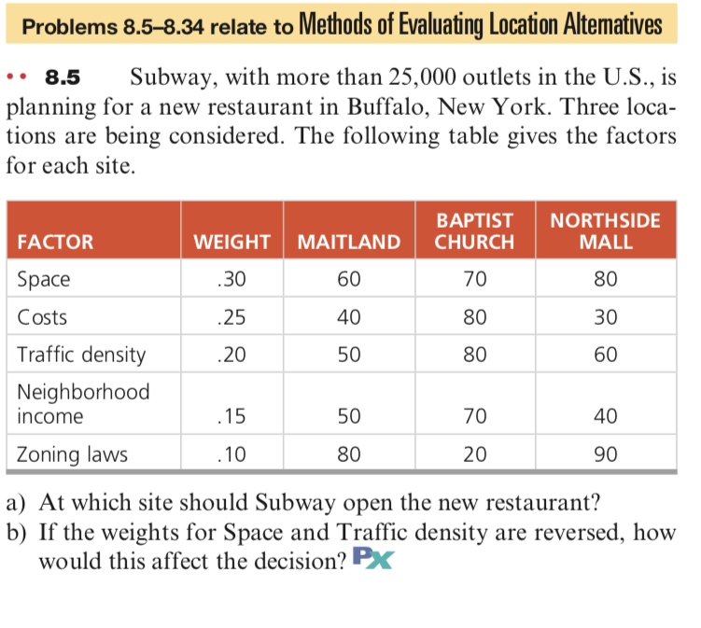

Problem 8.7
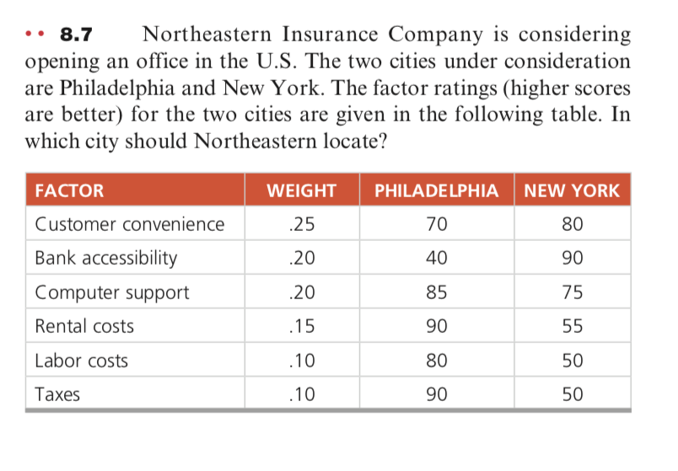

Problem 8.9
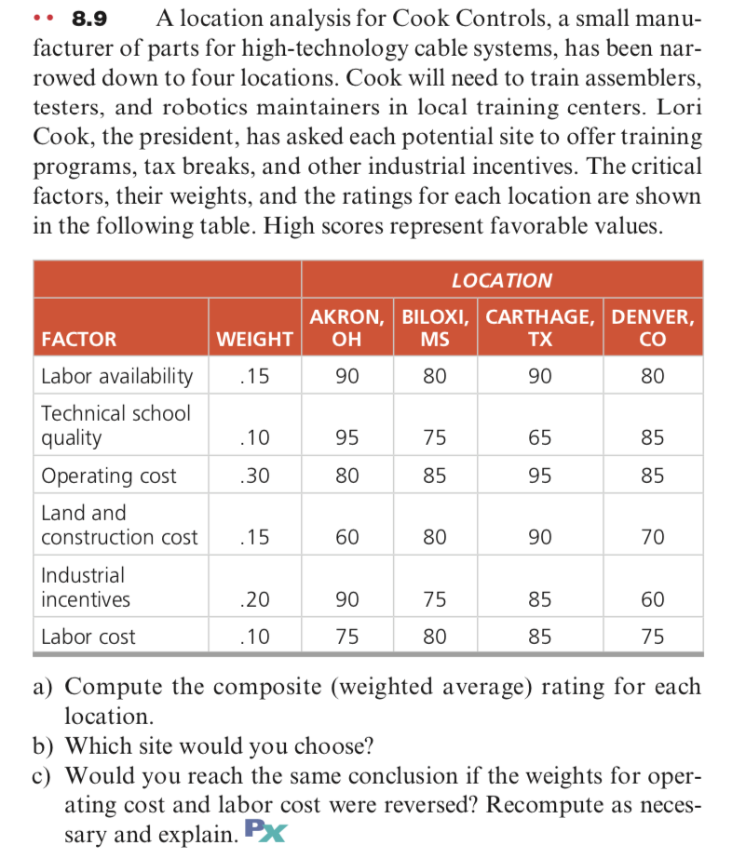

Problem 9.11
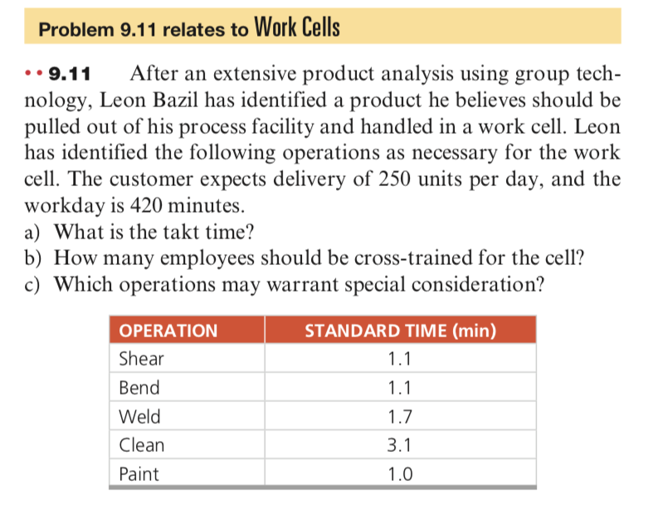

Problem 9.15
